modular polycarbone system

Technical manual
Part I. Roofs. Specification of elements

version 01; issue 01.2013 Technical department. Edited by A.P.Debabov

2013

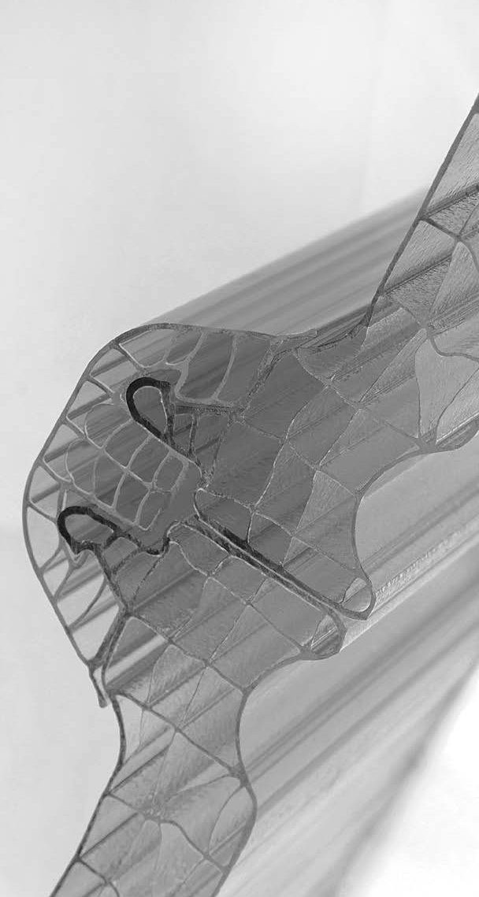

Modular polycarbone system
CARBOGLASSpro

Technical manual

Part I. Roofs. Specification of elements

version 01; issue 01.2013 technical department.
Edited by A.P.Debabov
2013

Part I Roofs. Specification of elements
Part II Roofs. Load
Part III Roofs. Transportation and storage
Part IV Roofs. Installation instruction
Part V Roofs. Units
Part VI Roofs. Maintenance manual
Part VII Facades. Specification of elements
Part VIII Facades. Loads
Part IX Facades. Transportation and storage
Part X Facades. Installation instruction
Part XI Facades. Units
Part XII Facades. Maintenance manual

Table of contents:

INTRODUCTION
3
General information

4 1 Components of the system
  - Modules
5
    - Standard dimensions

    - Specification of МСК10
6
    - Specification of МСК20
6

  - Connecting sections
7
    - Polycarbone clamping section (E-shaped section)
  - Cornice sections
    - Cornice section for К10 module

    - Cornice section for К20 module
8
    - Cleat for fastening of К10 modules (code КК10)

    - Cleat for fastening of К20 modules (code КК20)
9
1.4.4 End stainless steel plug
    - EPDM sealant (code У1)

Technical manual. Part I. Roofs. Specification of elements
3

      - INTRODUCTION
system of modular polycarbone covers • General information

Warning:
The information given in this edition is intended to serve as a reference for customers during designing and installation. The information is based on our experience and can be changed without prior notice.
The given information is not compulsory and does not release clients from independent check of applicability of the specified materials.
Should any questions and doubts concerning any aspects of application arise, the client should address to the experts of CJSC "Carboglass" beforehand.

introduction

Roof system from CARBOGLASSpro is system of polycarbone modules, used for creation of pitched and arched translucent roofs.

The system consists of cellular polycarbone modules (К10 or К20; the figure designates thickness of the panel in mm), connecting
E-shaped section, aluminum cornice, sealant, cleats made of stainless steel, and other parts. The system is independent and ready for installation, easy adjustable to structures of different types. The system features easy installation and high resistance to loads and environmental influences.

geneal information

Мск 10
System of translucent cover МСК10 consists of the following elements:
- к10 – cellular polycarbone 4-layer module with thickness of 10mm, with coextrusion UV protection on one side, with weight of 2,5 kg/m2, with reduced total thermal resistance R0=0,36m2*0С/Wt, colour – translucent «crushed ice» (or any other from CARBOGLASS catalogue, upon request), standard dimensions – width 600mm, length – any, upon request. The panel has 10 years warranty against damage by hail, loss o f transparency, and against yellowing.
- E-shaped section – polycarbone connecting section with UV protection.
- кк10 – stainless steel cleats (AISI 430)
- кП10 – cornice anodized aluminum section (thickness of protective coat – 15 micron)
- Aluminum plug for E-shaped section
- у1- EPDM sealant for cornice section

Мск 20
System of translucent cover МСК20 consists of the following elements:
- к20 - cellular polycarbone 5-layer module with thickness of 20mm, with coextrusion UV-protection on one side, with weight of 3 kg/m2, heat conduction R0=0,52м2*0С/Wt, colour – translucent «crushed ice» (or any other from CARBOGLASS catalogue, upon request), standard dimensions – width 600mm, length – any, upon request. The panel has 10 years warranty against damage by hail, loss of transparency, and against yellowing.
- E-shaped section – polycarbone connecting section with UV protection.
- кк20 - stainless steel cleats (AISI430)
- кП20 - cornice anodized aluminum section (thickness of protective coat – 15 micron)
- Aluminum plug for E-shaped section
- у1 - sealant for cornice section

Contact us for more information:
project@carboglass.ruwww.carboglass.pro

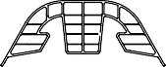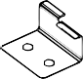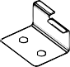 Technical manual. Part I. Roofs. Specification of elements 4
system of modular polycarbone covers • 1. Components of the system

Components of the system

name | general view | description | material
К10 |  | Roof module 10х600 | PC
К20 |  | Roof module 20х600 | PC
E-shaped section |  | Connecting section for roof modules | PC
КП10 |  | Cornice section, for module of 10mm, 0,6m | Al
КП20 |  | Cornice section, for module of 20mm, 0,6m | Al
plug |  | End plug for E-shaped section | Al
Cleat КК10 |  | Element for fastening of К10 panel to roof latten | NSt
Cleat КК20 |  | Element for fastening of К20 panel to roof latten | NSt
У1 |  | Universal sealant for seams between polycarbone modules and metal sections | EPDM

Technical manual. Part I. Roofs. Specification of elements
5

  - 1.1Modules
system of modular polycarbone covers • 1.1.1 Standard dimensions

Modules

CARBOGLASSpro roof module is cellular polycarbone panel made by extrusion method, with coextrusion UV-protection.

Clips on side faces of panels allow to connect them by means of a special clamping E-shaped section. Channels on the internal surface of modules
allow to use standard self-tapping screws D5,5 with wrench head for fastening. This facilitates installation and makes fastening joints very reliable. The system features leak tightness, transparency, high heat and technical parameters, and high bearing capacity.

standard dimensions

к10

к20

front face with UV protection

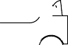

dimension | К10 | К20 | tolerance
Thickness (s) | 10 mm | 20 mm | ± 0.2 mm
Width (L) | 600 mm | 600 mm | ± 2.0 mm
Distance between stiffening ribs (As) | mm | mm | ± 0.5 mm
Height of clip (Ad) | mm | mm | ± 0.5 mm
Length | Acc. to request |  | +30 mm
Max. length | 13,500 mm, limited by transportation conditions
Standard weigth | 2.5 kg/m2 | 3 kg/m2 | ± 5 %

Technical manual. Part I. Roofs. Specification of elements
6

      - 1.1.2 Specification of MСК10
system of modular polycarbone covers • 1.1.3 Specification of МСК20

specification of Мск10
Reduced total thermal resistance | 0,36 m2 °C/Wt
colours | LT G
 | Translucent (8005) | 76% | 68%
 | Opal (8120) | 48% | 51%
 | Smoky white (8315) | 68% | 64%
 | Green (8012) | 64% | 73%
 | Blue (8022) | 63% | 72%
 | Smoky grey (8003) | 52% | 60%
 | Athermic (8667) | 31% | 40%
UV protection | Coextrusion, one-sided
Warranty | 10 years warranty of resistance to hail, yellowing, and loss of transparency
Operating temperature | -40°C +120°C
Thermal dilatation ratio | 0.065 mm/m °C (6.5×10-5m/m °K)
Fire behavior | standard | г3
 | FR | г1

LT = light transmission
G = transmission of solar energy

specification of Мск20
Reduced total thermal resistance | 0,52 m2 °C/Wt
colours | LT G
 | Translucent (8005) | 65% | 68%
 | Opal (8120) | 41% | 48%
 | Smoky white (8315) | 50% | 59%
 | Green (8012) | 61% | 65%
 | Blue (8022) | 60% | 64%
 | Smoky grey (8003) | 45% | 57%
 | Athermic (8667) | 17% | 34%
UV protection | Coextrusion, one-sided
Warranty | 10 years warranty of resistance to hail, yellowing, and loss of transparency
Operating temperature | -40°C +120°C
Thermal dilatation ratio | 0.065 mm/m °C (6.5×10-5m/m °K)
Fire behavior | standard | г3
 | FR | г1

LT = light transmission
G = transmission of solar energy

Technical manual. Part I. Roofs. Specification of elements
7

- 1.2 Connecting sections
system of modular polycarbone covers •1.3Cornice sections

connecting sections
    - Polycarbone clamping E-shaped section

E-shaped section is universal and is used for connecting of К10 or К20 modules with each other.
The section features coextrusion UV protection and
is installed on the outer side of the cover.

E-shaped section

Specification
Length | Upon request
Weight | 0.25 kg/m

  - Cornice sections
    - cornice section for к10 module

Cornice section fastens the system of existing bearing structure to the cornice frame and protects the lower end of the module from environmental influences. Cornice section has openings for fastening to roof latten with the help of self-tapping screws, as well as for fixing of

plugs of E-shaped section. Sealant tightly fixes the module in section. Standard type of surface treatment – anodizing. Upon request, the section can have any colour of RAL scale or be delivered non-treated.

кП10

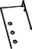
Specification
Length | 600 mm
Aluminum alloy | АД31
Area of section | 217 mm2
Weight | 570г
Thickness of coat | 15 µ
Tolerance | гОСТ22233-2001

Technical manual. Part I. Roofs. Specification of elements
8

      - 1.3 Cornice sections
с system of modular polycarbone covers • 1.4 Accessory

    - cornice section for к20 module

Cornice section fastens the system of existing bearing structure to the cornice frame and protects the lower end of the module from environmental influences. Cornice section has openings for fastening to roof latten with the help of self-tapping screws, as well as for fixing of

plugs of E-shaped section. Sealant tightly fixes the module in section. Standard type of surface treatment – anodizing. Upon request, the section can have any colour of RAL scale or be delivered non-treated.

кП20

Specification
Length | 600 mm
Aluminum alloy | АД31
Area of section | 217 mm2
Weight | 630г
Thickness of coat | 15 µ
Tolerance | гОСТ22233-2001

  - Accessory
    - cleat for fastening of к10 modules (code кк10)

This stainless steel cleat is intended for fastening of CARBOGLASSpro modular system to roof latten. The width of spans of the supporting structure should be at least 40mm. Cleats are installed in all points of intersection of the roof latten and the seams between modules. Spacing of fasteners depends on width of panels (600 mm) and spacing of roof latten.

Max. spacing of roof latten is calculated taking into account thickness of the panel and expected loads. Anchor is fastened by two self-tapping screws d5,5 with hexagon head, chosen on the basis of span type (wood, metal, etc.).

кк10

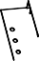

Specification
Dimensions, mm | 30x40x30
Openings for screws | 2 openings w Ø 6mm
Grade of stainless steel | AISI 430

Technical manual. Part I. Roofs. Specification of elements 9
system of modular polycarbone covers • 1.4 Accessory

cleat for fastening of к20 modules (code кк20)

    - end stainless steel plug

1.4.7 EPDM sealant (code у1)

This stainless steel cleat is intended for fastening of CARBOGLASSpro modular system to roof latten. The width of spans of the supporting structure should be at least 40mm. Cleats are installed in all points of intersection of the roof latten and the seams between modules. Spacing of fasteners depends on width of panels (600 mm) and spacing of roof latten).

End plug is used in the cornice part of the cover, for closing of E-shaped section’s end.
Specification
Dimensions, mm | 30x40x30
Openings for screws | 2 openings w Ø 6mm
Grade of stainless steel | AISI 430

Openings in plug walls allow to fix it on the cornce section by self-tapping screws and rivets.

Specification
Dimensions, mm | 140x65x55
Openings | 4 opening Ø 4 mm
Grade of aluminum | АД31

EPDM sealant is laid in the corresponding grooves of the cornice section and the aluminum plug for fixing of modules in the cornice unit.

Max. spacing of roof latten is calculated taking into account thickness of the panel and expected loads. Anchor is fastened by two self-tapping screws d5,5 with hexagon head, chosen on the basis of span type (wood, metal, etc.).

кк20

end plug

у1

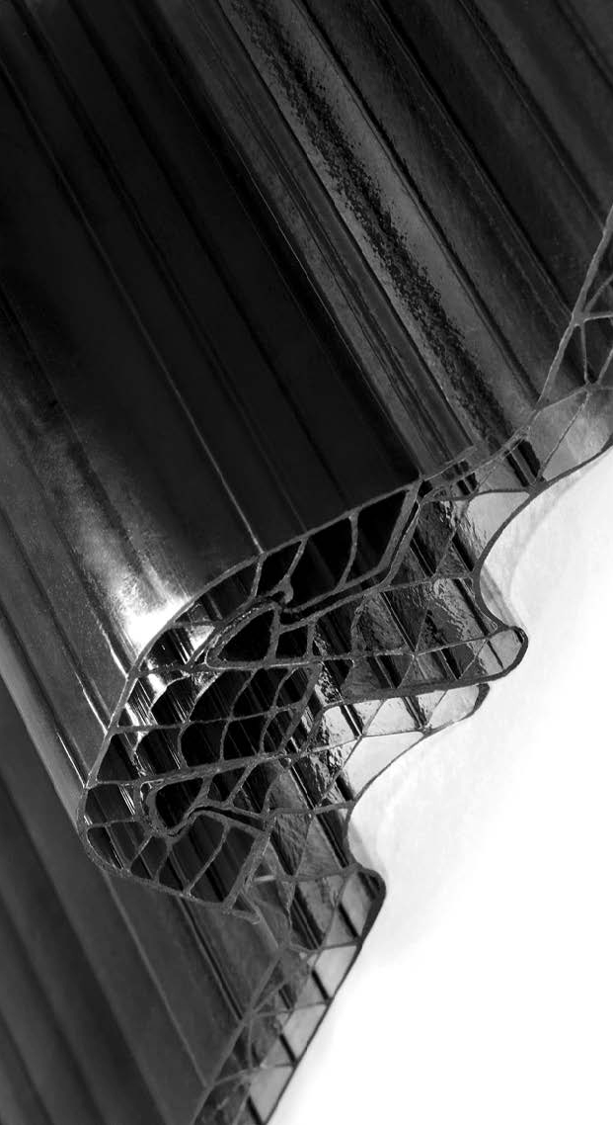

Please contact us for additional information:
project@carboglass.ruwww.carboglass.pro

