modular polycarbone system

technical manual

Part VII. Facades. Specification of elements

version 01; issue 01.2013 Technical department. Edited by A.P.Debabov

2013

Modular polycarbone system
CARBOGLASSpro

Technical manual

Part VII.Facades. Specification of elements

version 01; issue 01.2013 technical department.
Edited by A.P. Debabov
2013

Part I Roofs. Specification of elements
Part II Roofs. Load
Part III Roofs. Transportation and storage
Part IV Roofs. Installation instruction
Part V Roofs. Units
Part VI Roofs. Maintenance manual
Part VII Facades. Specification of elements
Part VIII Facades. Loads
Part IX Facades. Transportation and storage
Part X Facades. Installation instruction
Part XI Facades. Units
Part XII Facades. Maintenance manual

Table of contents:

Introduction
3
CARBOGLASSpro Ф40 façade system

Technical requirements
4
- Components of the system
  - Polycarbone modules

    - Standard dimensions
5
    - Specification

  - Aluminum sections
6
    - upper aluminum section(ФХв20)
    - lower aluminum section (ФXн20)
    - upper aluminum section (ФХв40)

    - lower aluminum section (ФXн40)
7
    - upper warm aluminum section (ФТв40)
    - lower warm aluminum section (ФТн40)

  - Cleats
8
    - Front stainless cleat(КФ20)
    - Front aluminum cleat (КФ40)

  - Sealants
9
    - Sealant(У-1) for sections of perimeter of the opening (upper, side, lower)
    - Inter-modular (У-2) sealant

Technical specification. Part VII. Facades. Specification of elements 3

system of modular polycarbone covers
- Introduction

Warning:
The information given in this edition is intended to serve as a reference for customers during designing and installation. The information is based on our experience and can be changed without prior notice.
The given information is not compulsory and does not release clients from independent check of applicability of the specified materials.
Should any questions and doubts concerning any aspects of application arise, the client should address to the experts of CJSC "Carboglass" beforehand.

CARBOGLASSpro Ф40 facade system

introduction

CARBOGLASSpro is a series of professional gazing systems for creation of light, translucent polycarbone structures. It is possible to choose roof and facade modular systems of polycarbone panels with various thickness, depending on constructive solutions and set building conditions (the necessary resistance to heat transmission and the bearing capacity).
CARBOGLASSproF20 and F40 is a modular system of polycarbone panels, intended for creation of translucent facade structure. The figure designates thickness of the module in millimeters.
Universal facade system CARBOGLASSproF is resistant to wind loads and easy in installation. The system.
The system consists of cellular polycarbone panels (modules) with thickness of 20 and 40mm, cold and warm aluminium frame sections, rubber sealants, and fixing aluminium cleats. The system can be applied for all kinds of vertical gazing, as well as for pitched glazing with pitch angle of more than 60 °.

Ф40 system is recommended for glazing of heated buildings. Modules are connected among each other acc. to "finger-groove" principle. Arrow-shaped form of finger joint of the modules ensures quick and reliable fixing of panels. Finger of Ф40 module has diagonal membranes which reinforce connection and provide heat insulation of the joint. The joint can be additionally sealed with special sealant - У2.
Significant thickness and combined orthogonal and diagonal, 10-walls structure provide Ф40 modules with high bearing capacity and excellent heat and technical properties.
The key advantages of the system are its small weight, high bearing capacity, extreme shock resistance, excellent heat protection, convenience, quick installation, and quite affordable price.

Technical specification. Part VII. Facades. Specification of elements
4
  - Technical requirements

system of modular polycarbone covers
- 7 Components of the system
- 7.1 Polycarbone modules

technical requirements

completing units of CARBOGLASS pro F20:
- Polycarbone cellular panel Ф20, acc. to ТУ5772-006-70212577-2013
- frame cold anodized aluminum sections acc. to гОСТ22233- 2001 (protective coat of at least 15 microns):

facade cold upper section ФХв20 facade cold lower section ФХн20 Stainless cleat КФ20
Sealant made of EPDM, rubber УФ1

completing units of CARBOGLASSproF40:
- Polycarbone cellular panel Ф40, acc. to ТУ5772-006-70212577-2013
- frame warm anodized aluminum sections acc. to гОСТ22233- 2001 (protective coat of at least 15 microns):
upper warm section ФТв40 lower warm section ФТн40
- frame cold anodized aluminum sections acc. to гОСТ22233- 2001 (protective coat of at least 15 microns):
cold upper section ФХв40 cold lower section ФХн40
Aluminum cleat КФ40 гОСТ22233-2001
- Sealant made of EPDM, rubber У1
- Sealant made of silicone У2

7 components of the system
7.1
Polycarbone modules

МФ20 and МФ40 are cellular polycarbone facade modules Type of joint – finger-groove

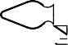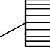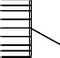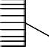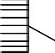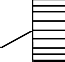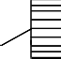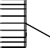
 |  |  |  |  |  |  |  |  |  |  |  |  |  |  |  |  |  |  |  |  |  |  |  |  |  | Cw | МФ20
 |  |  |  |  |  |  |  |  |  |  |  |  |  |  |  |  |  |  |  |  |  |  |  |  |  |  |  |  |  |  |  | t
W

Wm

Cw МФ40

t

W

Wm

Contact us for more information:
project@carboglass.ruwww.carboglass.pro

Technical specification. Part VII. Facades. Specification of elements
5

- 7.1.1 Standard dimensions
system of modular polycarbone covers • 7.1.2 Specification

7.1.1
Standard dimensions
 | Ф20 | Ф40 | Tolerance
Thickness (t) | 20 | 40 mm | ± 0.8 mm
Working width (W) | 500 | 500 mm | ± 2.0 mm
General width (Wm) | 515,5 | 540 mm | -7.0 +2.0 mm
Structure | Combined, orthogonal and diagonal
Number of walls | 5 | 10
Distance between ribs (Cw) | 15,1 mm | 20 mm | ± 0.5 mm
Length | Any, upon request |  | ± 4 mm
Max. length | 13.500 mm, limited by transportation conditions
Weigth | 3 kg/m2 | 4,2 kg/m2 | ± 7 %

7.1.2
Specifications

Characteristic |  | Ф20 | Ф40
Reduced total thermal resistance |  | 0,52 m2*С/Wt | 0,89 m2*С/Wt
Sound proofing |  | 18dBa | 21 dBa
Light transmission |  | 0,59 | 0,42
UV-protection |  | Coextrusion, on both sides
Warranty |  | 15 years warranty of resistance to hail, yellowing, and loss of transparency
Range of working temperatures |  | - 40° C до + 120° C
Tthermal dilatation ratio |  | 0.065 mm/m °C (6.5 x 10-5 m/m °С)
Fire behavior | standard | г3
 | FR | г1

Technical specification. Part VII. Facades. Specification of elements
6
      - 7.2.1 upper aluminum section (ФХв20)
      - 7.2.2lower aluminum section (ФXн20)
system of modular polycarbone covers • 7.2.3 upper aluminum section (ФХв40)

Aluminum sections

    - upper aluminum section(Фхв20)

The upper section serves for fixing of Ф20 modules along the upper edge of the opening and on both sides. Sealant is fixed to edges of the section. A special section's form provides tight adjunction of the panel. There are two positions of the section (designated with lines corresponding to axes of screws),

which allow fixing of the section in opening of a span, or on external surface of the facade. Standard type of surface treatment – anodizing. Section of any colour from RAL scale or non-treated section can be delivered upon request.

Фхв20

Specifications
Length | 6000 mm
Area of section, cm2 | 2,951
Weight of 1m, kg | 0,799
Alloy | АД31 гОСТ 4784-97
Anodizing | 15 µ
Tech. requirements | гОСТ 22233-2001

    - lower aluminum section (ФXн20)

The lower section serves for fixing of Ф20 modules along the lower edge of the opening. Sealant is fixed to edges of the section. A special section's form provides tight adjunction of the panel. There are two positions of the section (designated with lines corresponding to axes of screws), which allow to fix the section inside or outside of the opening.

Standard type of surface treatment – anodizing. Section of any colour from RAL scale or non-treated section can be delivered upon request. Section can be additionally equipped with a water bar, if necessary.

Фхн20

Specifications
Length | 6000 mm
Area of section, cm2 | 2,089
Weight of 1m, kg | 0,566
Alloy | АД31 гОСТ 4784-97
Anodizing | 15 µ
Tech. requirements | гОСТ 22233-2001

    - upper aluminum section (Фхв40)

The upper section serves for fixing of Ф40 modules along the upper edge of the opening and on both sides. Sealant is fixed to edges of the section. A special section's form provides tight adjunction of the panel. There are two positions of the section (designated with lines corresponding to axes of screws)

which allow fixing of the section in opening of a span, or on external surface of the facade. Standard type of surface treatment – anodizing. Section of any colour from RAL scale or non-treated section can be delivered upon request.

Фхв40

Specifications
Length | 6000 mm
Area of section, cm2 | 3,326
Weight of 1m, kg | 0,901
Alloy | АД31 гОСТ 4784-97
Anodizing | 15 µ
Tech. requirements | гОСТ 22233-2001

Technical specification. Part VII. Facades. Specification of elements
7
      - 7.2.4lower aluminum section (ФXн40)
- 7.2.5upper warm aluminum section (ФТв40)
- 7.2.65lower warm aluminum section (ФТн40)

lower aluminum section (ФXн40)

The lower section serves for fixing of Ф40 modules along the lower edge of the opening. Sealant is fixed to edges of the section. A special section's form provides tight adjunction of the panel. There are two positions of the section (designated with lines corresponding to axes of screws), which allow to fix the section inside or outside of the opening

Section can be additionally equipped with a water bar, if necessary. Standard type of surface treatment – anodizing. Section of any colour from RAL scale or non-treated section can be delivered upon request.

Фхн40

Specifications
Length | 6000 mm
Area of section, cm2 | 2,464
Weight of 1m, kg | 0,668
Alloy | АД31 гОСТ 4784-97
Anodizing | 15 µ
Tech. requirements | гОСТ 22233-2001

    - upper warm aluminum section (Фтв40)

The upper section serves for fixing of Ф40 modules along the upper edge of the opening and on both sides. Sealant is fixed to edges of the section. A special section's form provides tight adjunction of the panel. Thermal break prevents formation of cold bridges. There are two positions of the section (designated

with lines corresponding to axes of screws), which allow fixing of the section in opening of a span, or on external surface of the facade. Standard type of surface treatment – anodizing. Section of any colour from RAL scale or non-treated section can be delivered upon request.

Фтв40

Specifications
Length | 6000 mm
Area of section, cm2 | 5,74
Weight of 1m, kg | 1,382
Alloy | АД31 гОСТ 4784-97
Anodizing | 15 µ
Tech. requirements | гОСТ 22233-2001

    - lower warm aluminum section (Фтн40)

The lower section serves for fixing of MФ40 modules along the lower edge of the opening. Sealant is fixed to edges of the section. A special section's form provides tight adjunction of the panel. Thermal break prevents formation of cold bridges. There are two positions of the section (designated with lines corresponding to axes of screws),

which allow to fix the section inside or outside of the opening. Standard type of surface treatment – anodizing. Section of any colour from RAL scale or non-treated section can be delivered upon request.
Section can be additionally equipped with a water bar, if necessary.

Фхн20

Specifications
Length | 6000 mm
Area of section, cm2 | 5,2
Weight of 1m, kg | 1,234
Alloy | АД31 гОСТ 4784-97
Anodizing | 15 µ
Tech. requirements | гОСТ 22233-2001

Technical specification. Part VII. Facades. Specification of elements
8
- 7.3 Cleats•7.3.1 Frontal stainless cleat

system of modular polycarbone covers
(КФ20) • 7.3.2 Frontal aluminum cleat (КФ40)

Cleats

    - frontal stainless cleat (кФ20)

Steel frontal cleat КФ20 allows to fasten Ф20 modules to spans in cases when modules are not self-bearing. As a result, a facade of significant height can be formed.
Fasteners are installed between supporting structure and module, in each point of crossing of inter-modular joint with cross-section spans. Fastening of this type is resistant to considerable wind loads, which allows the modules to move along the vertical axis easily, and to compensate thermal dilatation of polycarbonate.

The maximum spacing between spans is defined taking into account expected loads (see part VIII). Each cleat is fastened by at least three self-tapping screws (Ø 5 mm) chosen according to type of span's material (self-tapping screws for wood, metal, anchor bolts for reinforced concrete, etc.).

кФ20

Specification
Length, mm | 50
Opening for self-tapping screws | 3 openings Ø 6 mm
Alloy | АД31 гОСТ 4784-97
Area, mm2 | 353,6
Weight, g | 48
Tolerance | гОСТ 22233-2001

    - кляммер фронтальный алюминиевый (кФ40)

Steel frontal cleat КФ40 allows to fasten Ф40 modules to spans in cases when modules are not self-bearing. As a result, a facade of significant height can be formed.
Fasteners are installed between supporting structure and module, in each point of crossing of inter-modular joint with cross-section spans. Fastening of this type is resistant to considerable wind loads, which allows the modules to move along the vertical axis easily, and to compensate thermal dilatation of polycarbonate

The maximum spacing between spans is defined taking into account expected loads (see part VIII). Each cleat is fastened by at least three self-tapping screws (Ø 5 mm) chosen according to type of span's material (self-tapping screws for wood, metal, anchor bolts for reinforced concrete, etc.).

кФ40

Specification
Length, mm | 50
Opening for self-tapping screws | 3 openings Ø 6 mm
Alloy | АД31 гОСТ 4784-97
Area, mm2 | 353,6
Weight, g | 48
Tolerance | гОСТ 22233-2001

Technical specification. Part VII. Facades. Specification of elements
9
      - 7.4 Sealants

system of modular polycarbone covers
- 7.4.1 Sealant (У-1)
- 7.4.2 Sealant (У-2)

This sealant is made of silicone (compatible with polycarbonate) and should be installed into inter-modular joints, from the internal side of the facade. У-2 ensures additional leak tightness of the joints and is used for raised requirements to heat and technical properties of the structure.
7.4.2
Inter-modular sealant (у-2)
7.4 Sealants
7.4.1
sealant (у-1) for sections of opening’s perimeter профилей периметра проема | This sealant is made of EPDM rubber (compatible with polycarbonate) and should be installed into special grooves in lower, upper, and side sections. The sealant ensures leak tightness ерметичность | у-1
(upper, | of the system, as well as easy and reliable fixing of
Side, and lower) | modules in the frame section.

у-2

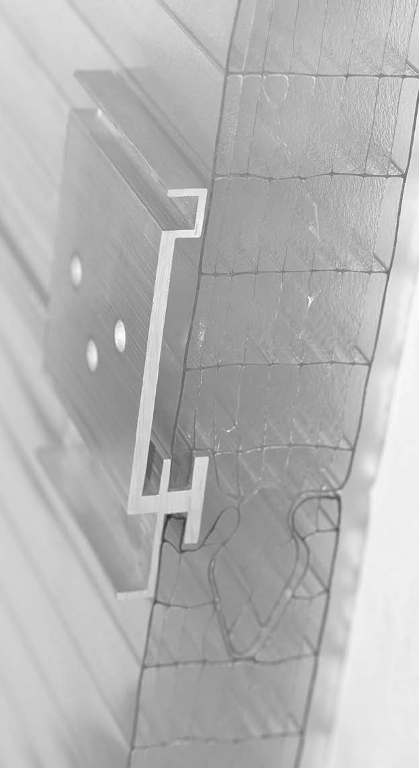

Contact us for more information:
project@carboglass.ruwww.carboglass.pro

